Community Bulletin

## Reimagining Blind Creek - January 2023

In Melbourne, rivers and creeks are essential to our way of life. That’s why we are committed to enhancing life and liveability in your local area and reimagining Blind Creek. As well as improving water quality, this project will open the space up for the community to enjoy now and for generations to come.

Melbourne Water is leading the project in partnership with Knox City Council.

|  |
| --- |
| Stage 1 (February-July 2023) |
| 1.1 Bridge construction |
| 1.1 Seating nodes |
| 1.1 New concrete/gravel paths |
| 1.1 General landscaping |
| 1.1 Revegetation installation |
| 1.2 & 1.3 Wetland construction with connection to Blind Creek |
| 1.2 & 1.3 New gravel paths |

# What are we doing in Stage 1?

We are installing new sections of shared footpath in all sections of Stage 1 to better connect active transport in the area. This will create additional paths for the community to enjoy the open space, with seating nodes, a new bridge and wetland construction included as part of these works.

There will be some minor vegetation removal to enable bridges and platforms to be constructed.

The project will plant a total of 1700 new trees and plants within the project area to improve shading and cooling in the area.

# When are the works happening?

Works for this stage will begin the week commencing **Monday 30 January** and are expected to finish in July 2023.

# What to expect

* Shared path access will be maintained to pedestrians and cyclists at all times. If shared paths do need to be closed for any reason, this will be communicated and we will ensure there are clear divisions in place.
* Temporary fencing will be set up around the construction areas.
* A small site compound will be established each of the Stage 1 project areas.
* There will be an increase in heavy and light vehicle traffic on **Parkhurst Drive** and surrounding areas as vehicles transport soil offsite and deliver materials to assist with job construction.
* There will be short-term increase in noise and dust. We will use a range of measures to reduce these impacts. We will monitor noise and dust levels throughout works.

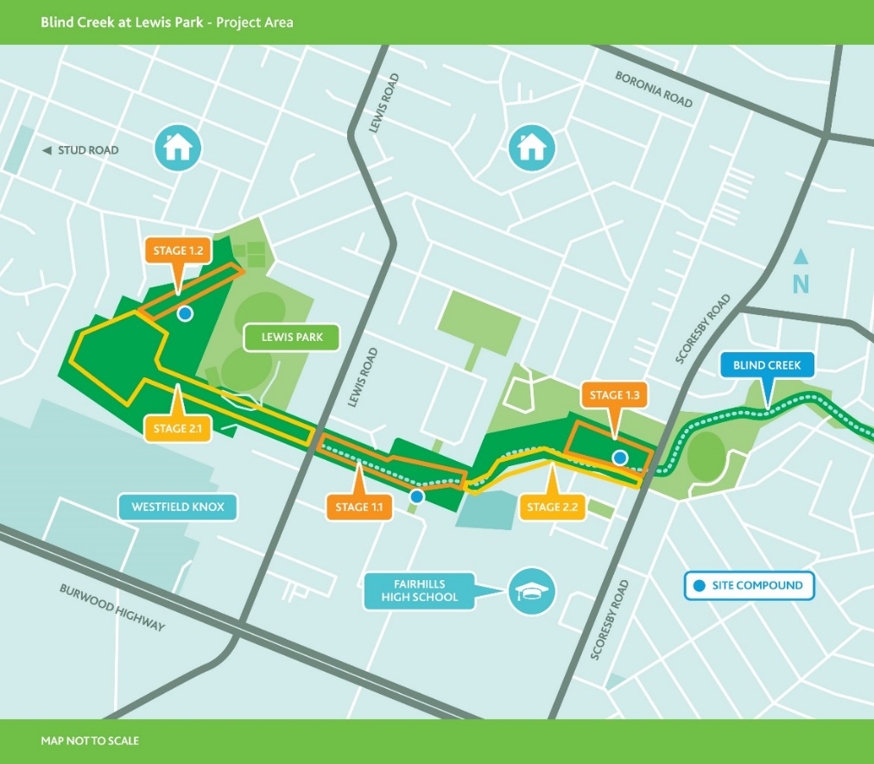

# When are we working?

Works will be undertaken between:

* 7am to 6pm Monday to Friday
* 7am to 5pm Saturdays

On occasions we may need to undertake works out of hours. We will notify you in advance if these works are required. The timings of these works are weather dependant.

# What’s next?

We will continue to keep the community updated on progress and upcoming works for further stages of the Reimagining Blind Creek project and thank you for your patience.

|  |  |
| --- | --- |
| **Keep up to date with what’s happening**  For more information about this project  or our other activities please call 1800 875 344 or visit melbournewater.com.au/building-and-works/projects/reimagining-blind-creek-lewis-park  For an interpreter, please call the Translating and Interpreting Service (TIS National) on 13 14 50 | **Like us**  facebook.com/melbournewater  **Follow us**  @MelbourneWater  **Visit us**  www.melbournewater.com.au |